ISBI 2018

You are cordially invited to attend the International Symposium on Biomedical Imaging Conference of the IEEE Engineering in Medicine and Biology Society, ISBI’18. The Conference is being held April 4-7 2018, at the Omni Shoreham Hotel in Washington DC. ISBI is a joint initiative of the IEEE Signal Processing Society (SPS) and IEEE Engineering in Medicine and Biology Society (EMBS)

Bio imaging has continued to evolve across a wide spectrum of applications from diagnostics to personalized therapy to mechanistic understanding of biological processes. The field continues to be challenged with ever increasing demand on more robust methods and integration with clinical and molecular data

Please note that this invitation for participation does not, in any way, financially oblige either ISBI’18 or the IEEE Engineering in Medicine and Biology Society (EMBS) for the expenses you incur for travel and conference attendance, and all conference participants are expected to pay the registration fees according to conference policy.

Please visit http://biomedicalimaging.org/2018/ to learn more. We look forward to your participation in ISBI’18!

Sincerely,

 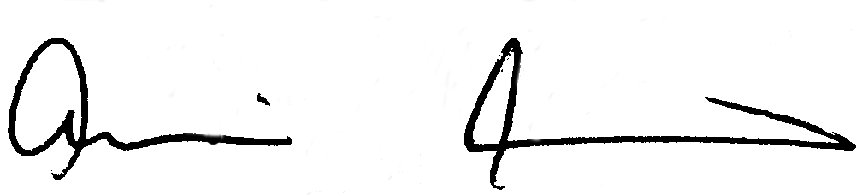

Scott Acton

University of Virginia

ISBI’18 Conference Co-Chair

Amir Amini

University of Louisville

ISBI'18 Conference Co-Chair